# Math for Developers – Exercise

The goal of this exercise is to practice **converting numbers from decimal to binary numeric system**. Your task is to convert your name to binary using the given ASCII table.

## Convert the characters of your name into decimal values

Your first task is to convert each of your characters to integer numbers using the given **ASCII table**.

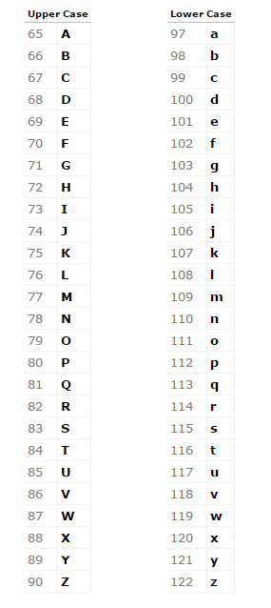

E.g. the name **Alex** is converted to: **65**, **108**, **101**, **120**. The character '**A**' has a numeric value of **65**, the character '**l**' has the numeric value of **108** and so on. Keep in mind that lowercase and uppercase letters matter!

## Converting the numbers from decimal to binary system

The numbers you get after converting your name are in decimal numeric system. In order to **convert** a **decimal** number to its **binary** format you need to implement the following **algorithm**:

1. **Divide** the decimal number by **2**.
2. We get the **remainder** of the operation and **write it down**.
3. If the **product** of the division is a number **different** than **0** we go back to **point 1**.
4. If the **product** of the division is **equal** to **0** we stop.
5. After we have **finished** the division, we **take the remainders** and **arrange** them in the following manner:

|  |
| --- |
| The number we want to convert is 23.  23/2 = 11 and **(1)** remainder  11/2 = 5 and **(1)** remainder  5/2 = 2 and **(1)** remainder  2/2 = 1 and **(0)** remainder  1/2 = 0 and **(1)** remainder  Now we take the produced remainders and arrange them by taking the last remainder then the second last, etc. and placing them one next to the other from left to right: **10111**.  The final number **10111** is the **binary** representation of the number **23** in **decimal** system. |

## Implement the algorithm for each number

After we have converted our name into numbers we need to **convert** **each** **number** to **binary**. After we do that we get our full name with zeros and ones.

E.g. the name **Alex** becomes:

01000001 01101100 01100101 01111000